Réglage du PID

Pierre Bomel, Université de Bretagne Sud, Lab-STICC, Lorient, France, mai 2021

Tests pour le KP

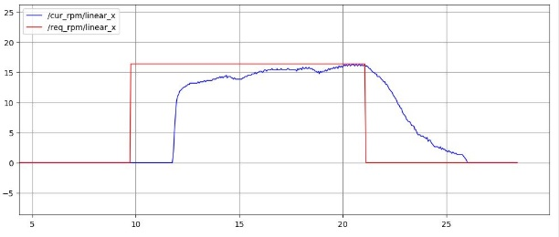 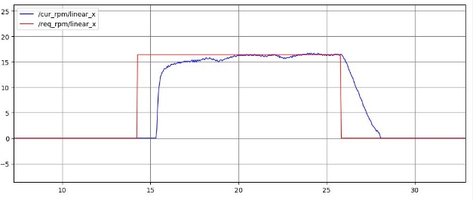

KP = 0.1 KP = 0.2

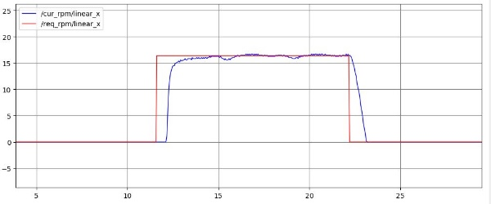 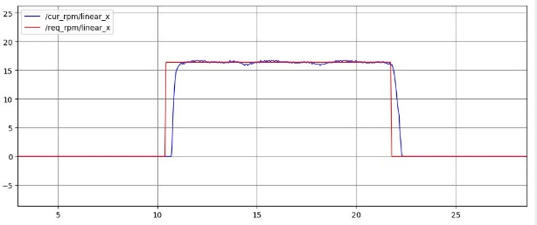

KP = 0.4 KP = 0.8

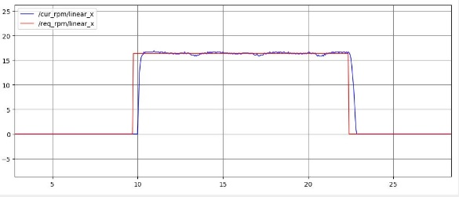 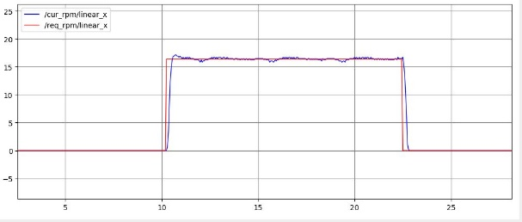

KP = 1.0 KP = 2.0

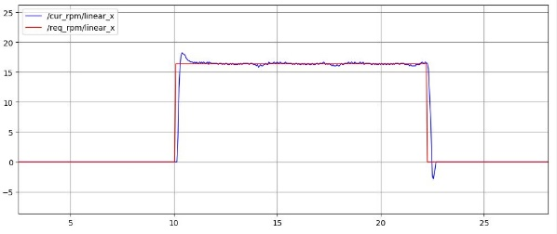 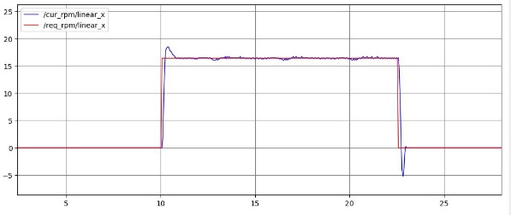

KP = 3.0 KP = 4.0

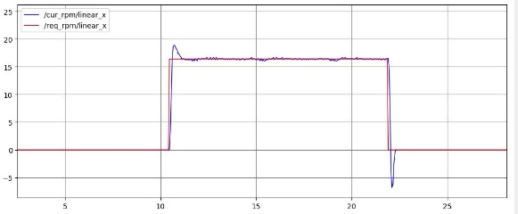 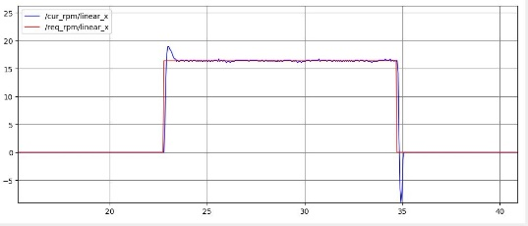

KP = 5.0 KP = 6.0

Choix => KP = 1.0

Tests pour KD (KP = 1.0)

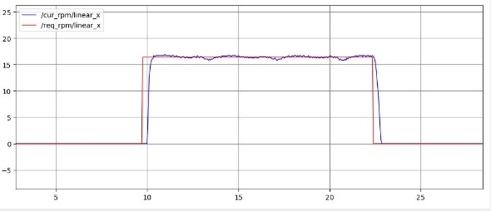 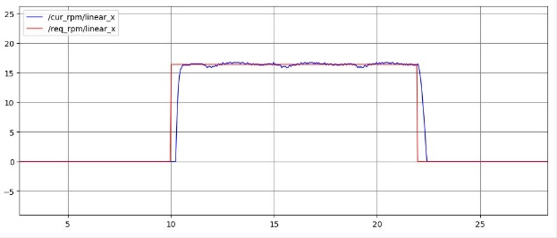

KD = 0.0 KD = 0.1

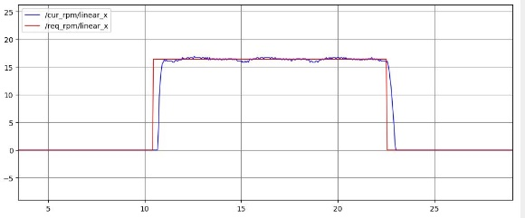 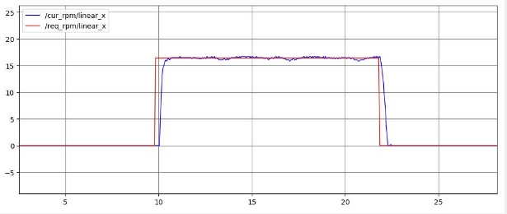

KD = 0.2 KD = 0.4

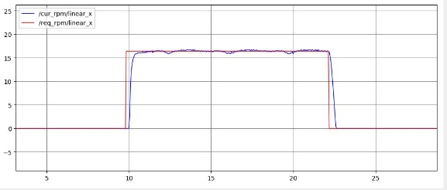

KD = 0.8 Pas de différences notables => KD = 0.1

Tests pour KI (KP = 1.0, KD = 0.1)

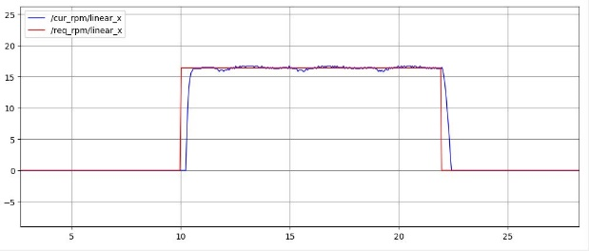 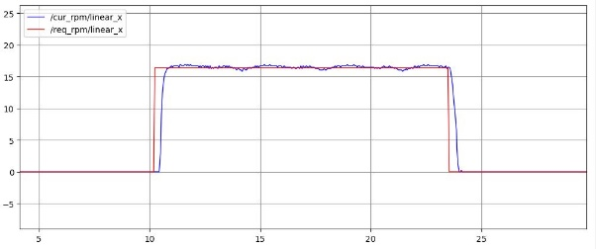

KI = 0.0 KI = 0.001

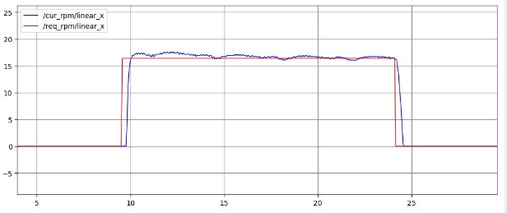 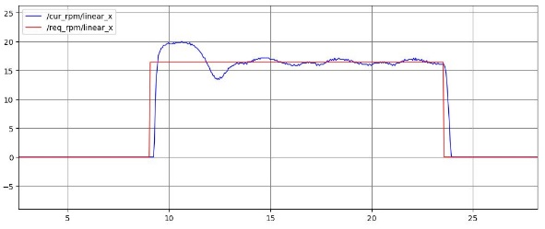

KI = 0.01 KI = 0.1

Choix => KI = 0.001

Tests pour KD (KP = 3.0)

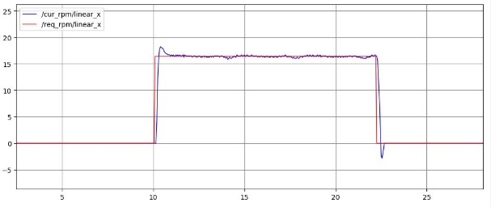 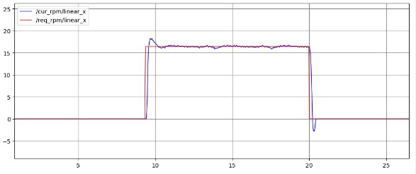

KD = 0.0 KD = 0.1

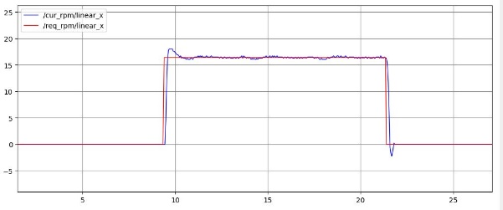 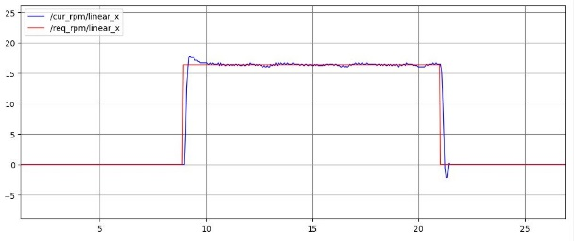

KD = 0.2 KD = 0.4

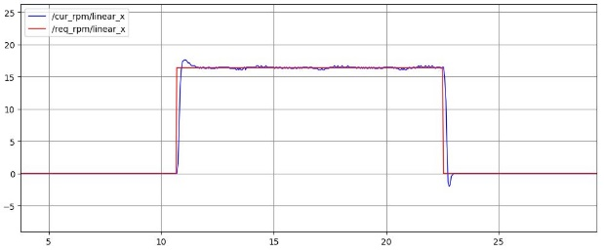 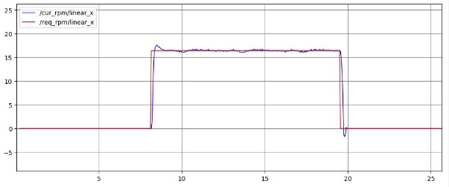

KD = 0.8 KD = 1.0

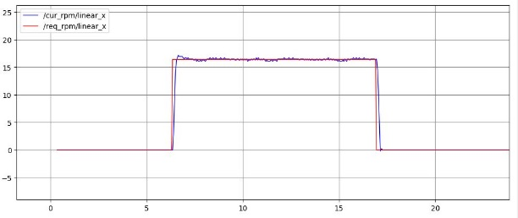 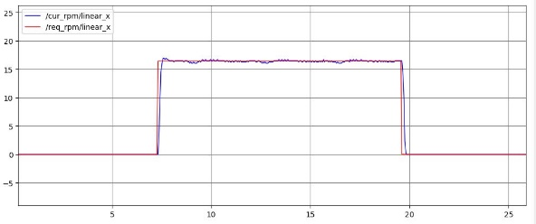

KD = 1.5 KD = 2.0

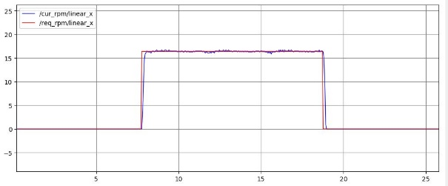 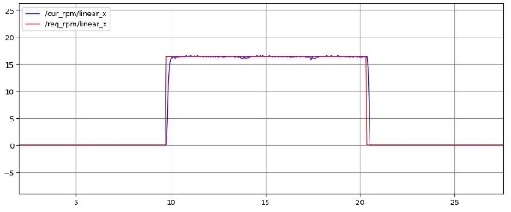

KD = 2.5 KD = 3.0

Choix => KD = 2.5

Tests pour KI (KP = 3.0, KD = 2.5)

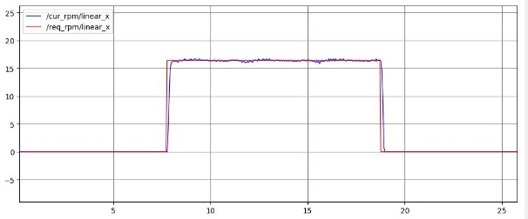 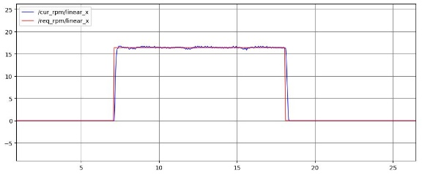

KI = 0.0 KI = 0.001

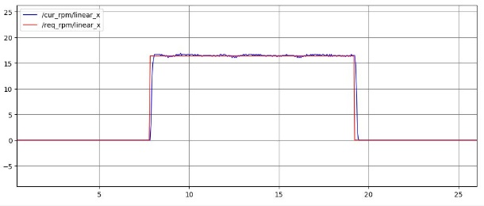 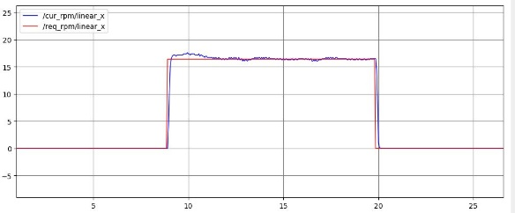

KI = 0.01 KI = 0.1

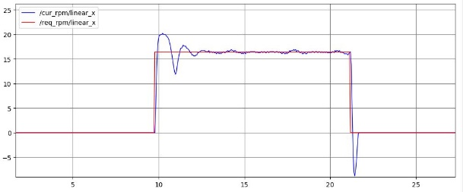

KI = 1.0

Choix => KI = 0.001